**Submitted by: Submitted to:**

**NAME: Rahul Gusain Hitesh Kumar Sharma**

**SAP: 500084143**

**ROLL NO.: R214220900**

**BATCH: 1 DevOps**

# **Application Containerization & Orchestration Lab**

# 

**LAB EXERCISE 1**

**AIM: Installing Vagrant & Creating basic vagrant box using Virtual Box**

**virtualization.**

**Steps to Complete:**

1. Download and Install Oracle Virtual Box 5.x and Vagrant 2.2.7.

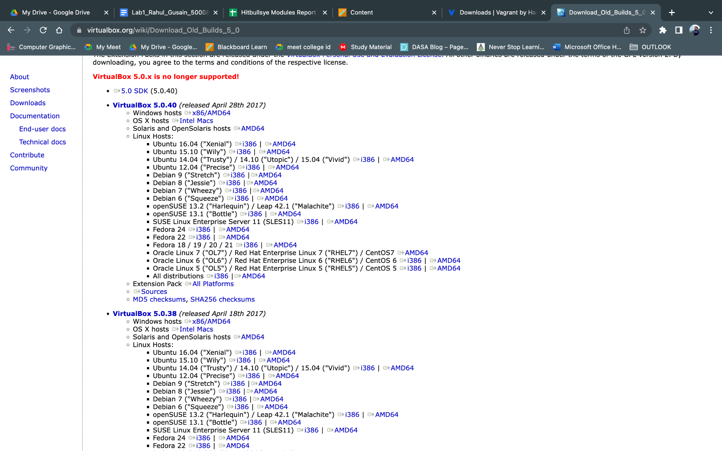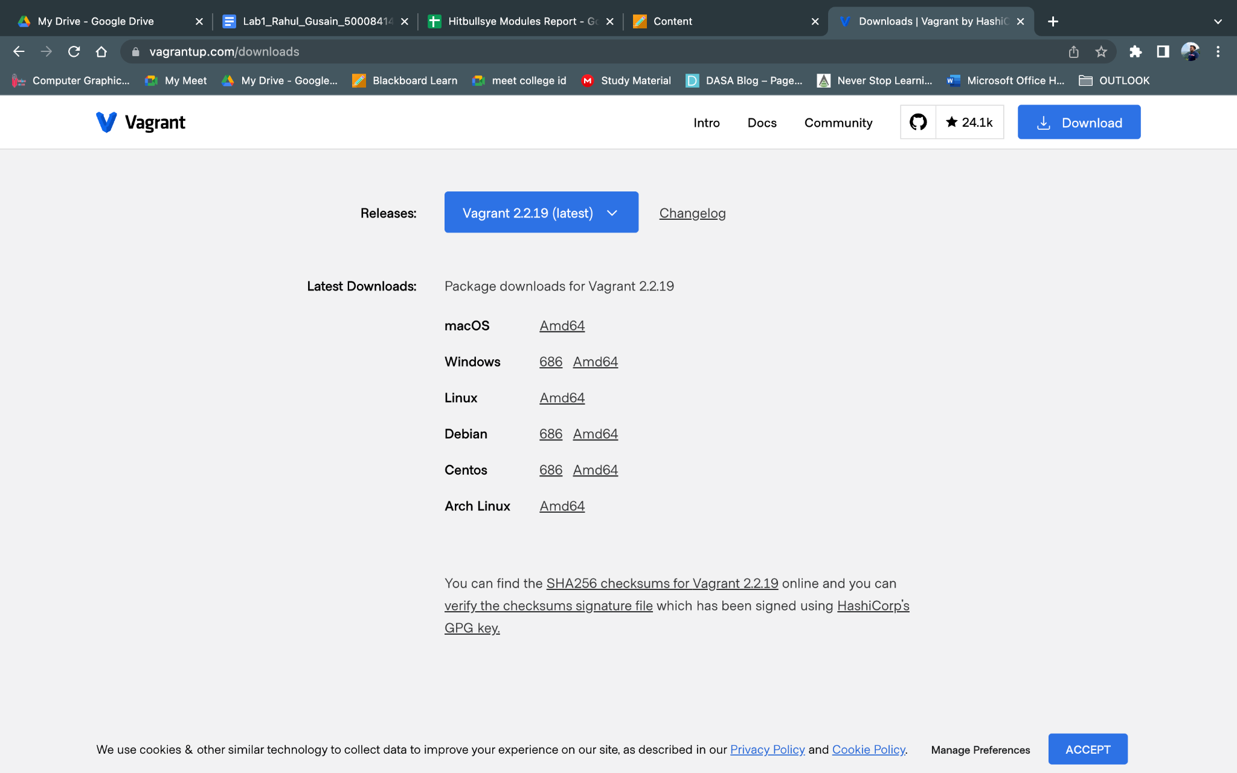

2. Check working of Vagrant using vagrant --version command.

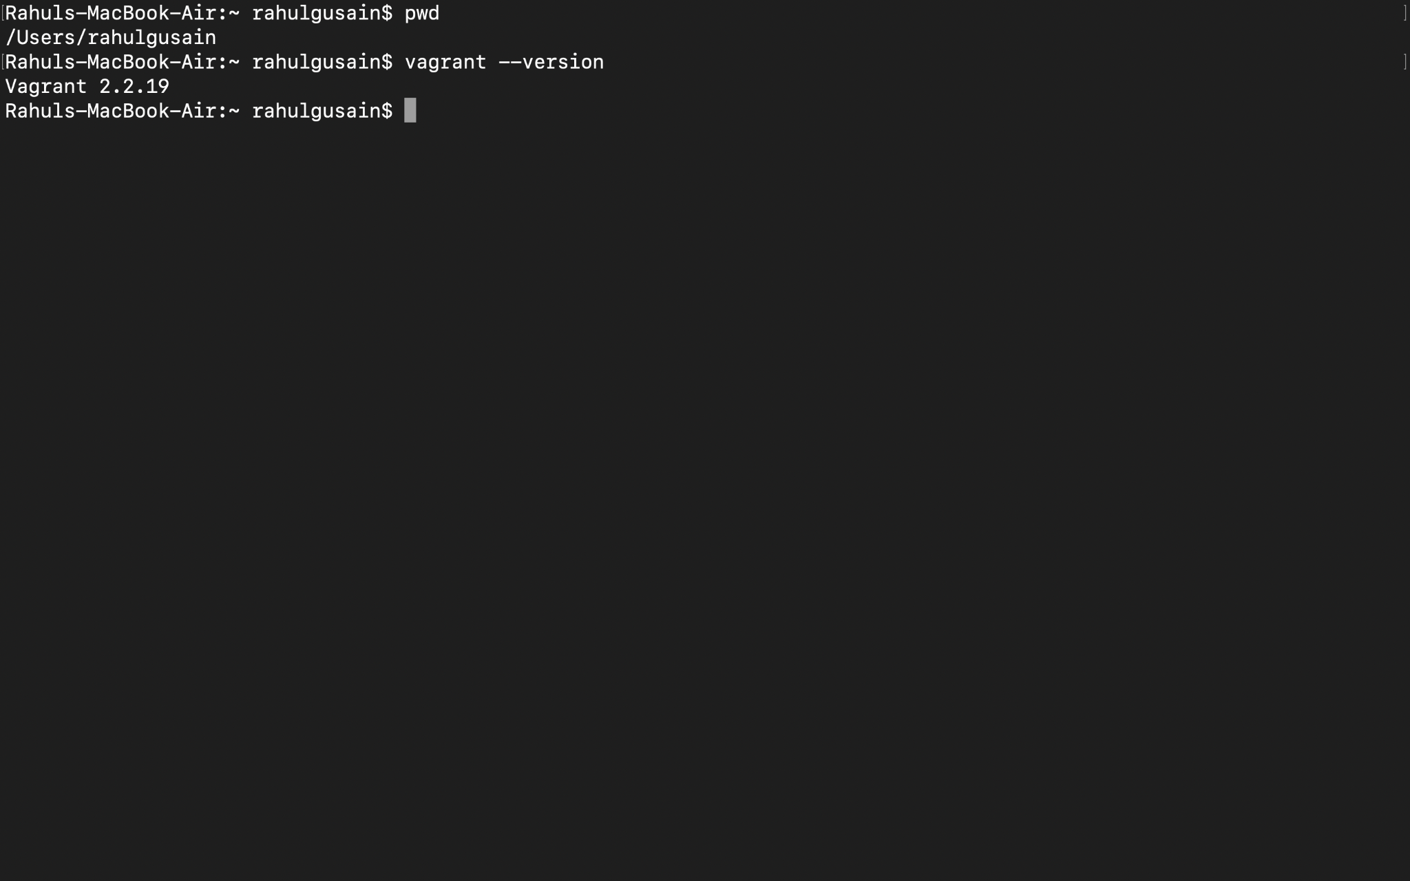

3. Create a new directory using CMD.

4. Run vagrant init command

5. Edit vagrantfile and add ubuntu/xenial64 in box tag.

6. Run vagrant up command

7. Run vagrant SSH command

8. Run Vagrant Halt to stop VM

9. Run Vagrant Destroy to delete VM